**Lab 4**

**Exchange Keyword**

**2. To create a program for Exchange the value between different registers.**

. model small

. stack 100h

. code

start:

mov al, 49 ; ascii code of 1

mov bl, 50

xchg al,bl

mov ah,02

mov dl,al

int 21h

mov ah,02

mov dl,bl

int 21h

Mov ah, 4ch

Int 21h

end start

**Task 1: Create a program with any new mnemonic.**

**Source Code:**

.model small

.stack 100h

.data

.code

start:

xchg al,bl

mov ah,01

int 21h

mov bl,al

mov ah,01

int 21h

mov ah,02

mov dl,al

int 21h

mov ah,02

mov dl,bl

int 21h

mov ah,4ch

int 21h

end start

**Output:**

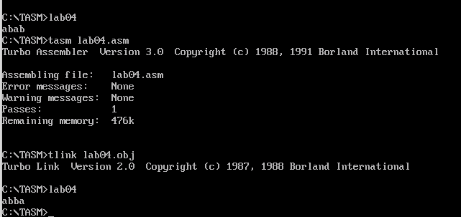

**Task 2: Create a program which exchange characters.**

**Source Code:**

.model small

.stack 100h

.data

.code

start:

mov al, 65

mov bl, 66

xchg al,bl

mov ah,02

mov dl,al

int 21h

mov ah,02

mov dl,bl

int 21h

Mov ah,4ch

Int 21h

end start

**Output:**

